MA document

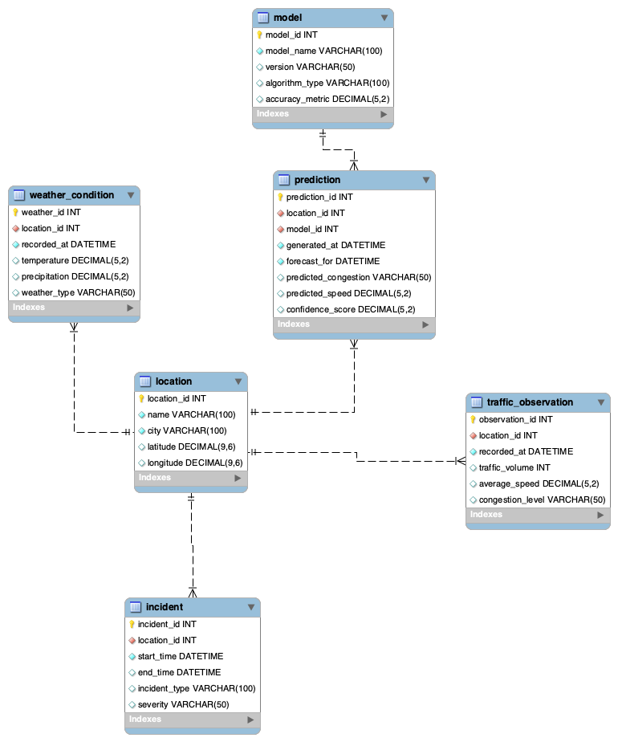
The Smart-Jam database is designed to support the collection, storage, and analysis of traffic-related data for short-term traffic congestion prediction. It stores information about monitored locations, real traffic observations, weather conditions, incidents affecting traffic flow, machine learning models, and generated predictions. The database allows the system to analyze current road conditions and produce forecasts for the next 30–60 minutes.
The system consists of several interconnected tables:
- Location – stores information about monitored road locations, including the location name, city, and geographic coordinates.
- Traffic Observation – records real traffic data for a specific location and time, such as traffic volume, average speed, and congestion level.
- Weather Condition – stores weather-related data for a location and time, including temperature, precipitation, and weather type.
- Incident – contains information about traffic-related events that may influence road conditions, such as accidents or roadworks, together with their severity and duration.
- Model – stores information about the forecasting models used in the system, including model name, version, algorithm type, and accuracy metric.
- Prediction – contains generated traffic forecasts for specific locations and times, including predicted congestion, predicted speed, and confidence score.
The relationships between these entities reflect the main logic of the system. A single location can have multiple traffic observations, weather records, incidents, and predictions. Each prediction is generated by one specific model. This structure ensures clear organization of input data and forecasting results while keeping the database simple and suitable for the project scope.

Slide 1

Title: Complete ER Diagram

On slide: full diagram only

Slide 2

Title: Location and Input Data

On slide:
- location
- traffic_observation
- weather_condition
- incident

Bullets:
- Location is the core entity.
- One location has many observations.
- One location has many weather records.
- One location has many incidents.

Slide 3

Title: Prediction and Model

On slide:
- prediction
- model
- location

Bullets:
- Each prediction belongs to one location.
- Each prediction is generated by one model.
- One model can create many predictions.

Slide 4

Title: Database Logic

Bullets:
- Traffic data are linked to locations.
- Weather and incidents provide context.
- The model generates short-term predictions.
- The database supports traffic forecasting.

Slide 5

Title: Cardinality Summary

Bullets:
- location → traffic_observation = 1:N
- location → weather_condition = 1:N
- location → incident = 1:N
- location → prediction = 1:N
- model → prediction = 1:N

